Custom Training

Day 5

Resource Group

* A logical container

**Azure Storage Account:**

* Premium Account
  + Page Blobs
  + File Shares
  + Block Blobs

Azure Storage Redundancy Types:

LRS:- Within the same data center there are multiple copies of the data

ZRS: There are multiple zones within a data center separated by a certain distance.

Each zone has a copy of the data.

GRS: Within a region pair where the regions are separated by a distance of 300 Km, there are copies of the data.

Data duplication happens synchronously 3 times in a date center by default.

GZRS: Data backup in the three zones of primary region as well as other region’s single zone.

In LRS, ZRS, GRS, GZRS, all three backup copies are made synchronously.

Read Access Geo Redundant Storage(RA-GRS): Users get access to the Secondary storage directly instead of the primary storage.

The benefit of this is that the read operation can happen simultaneously.

Replication is different from write operation.

In case of critical failure in the primary storage, the delay in the switchover from primary to secondary storage can take some time which might result in loss of data.

RAGRS prevents this and provides seamless servicing.

SLA: Service Level Agreement

The type of service the cloud service providers agree to provide.

* Depending on the amount paid, different levels of services are provided.
* GA: General Availability
* Endpoint: the link that connects to a resource
* Upstream & Downstream
  + Upstream is where the data comes from
  + Downstream is where the data will be sent after due transformation.
* SFTP is not available for BLOB.
  + It is only available for hierarchical namespace.
* Subscriber is called tenant.
  + Communication between tenants is called cross-tenant communication.
  + Replication of data from one tenant to another is called cross-tenant replication.
  + Tenant ID is used for cross-tenant replication.

Access Tier:

Hot: frequently accessed data (frequently)

Cool: infrequently accessed data and backup scenarios (min 30 days)

Cold: infrequently accessed data for longer period than cool (min 90 days)

Archive: long-term storage of data (min 180 days)

In hot more is paid for storage so less is incurred on accessing the data

In cold less is paid for storage so more is incurred on accessing the data

Purging of data(deleting)/Archiving happens to release storage.

ADLS Gen2: In Big Data processing, the data is present in multiple subfolders.

To allow the creation of subfolders, ADLS Gen2 need to be used

Azure Data Lake Storage Gen2(ADLS Gen2)

To create a Gen2, go to storage account, create, Advanced tab, enable hierarchical namespace.

The above will cause the creation of Gen2 storage.

Sub folders are not available in BLOB storage that is why ADLS Gen2 is used

A container can also be created to store this ADLS Gen2 instance.

Access permissions in ADLS Gen2

Read

Write

Execute

Soft delete:

If something is delete using soft delete, the files can be retrieved within the next 7 days.

BLOB change feed:

The number of days for which the data is maintained. Before that threshold the data is deleted

Azure CosmosDB: is used for all kinds of data storage.

Creation of storage account:

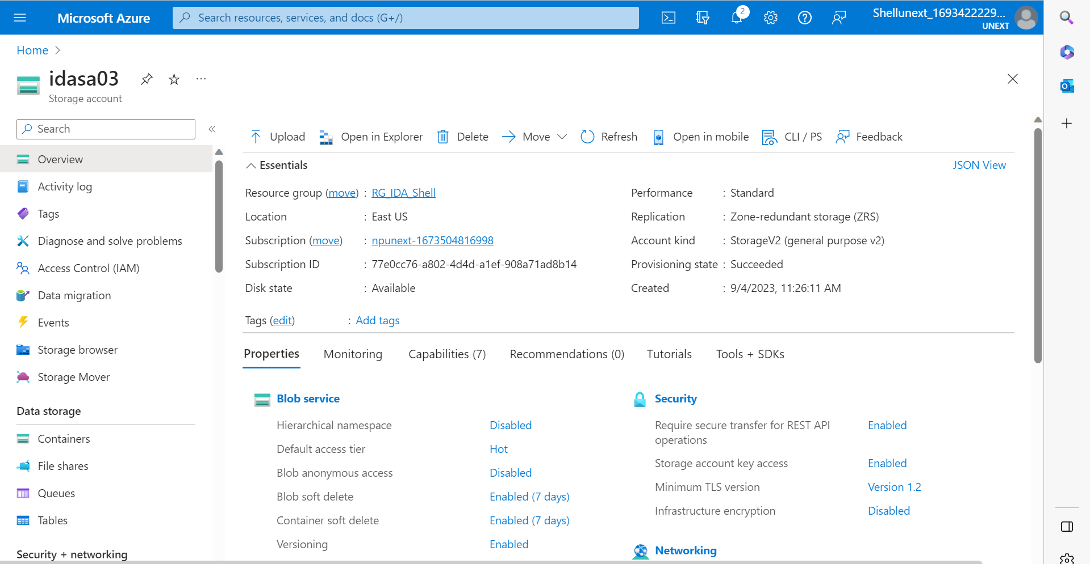

Creation of ADLS Gen2:

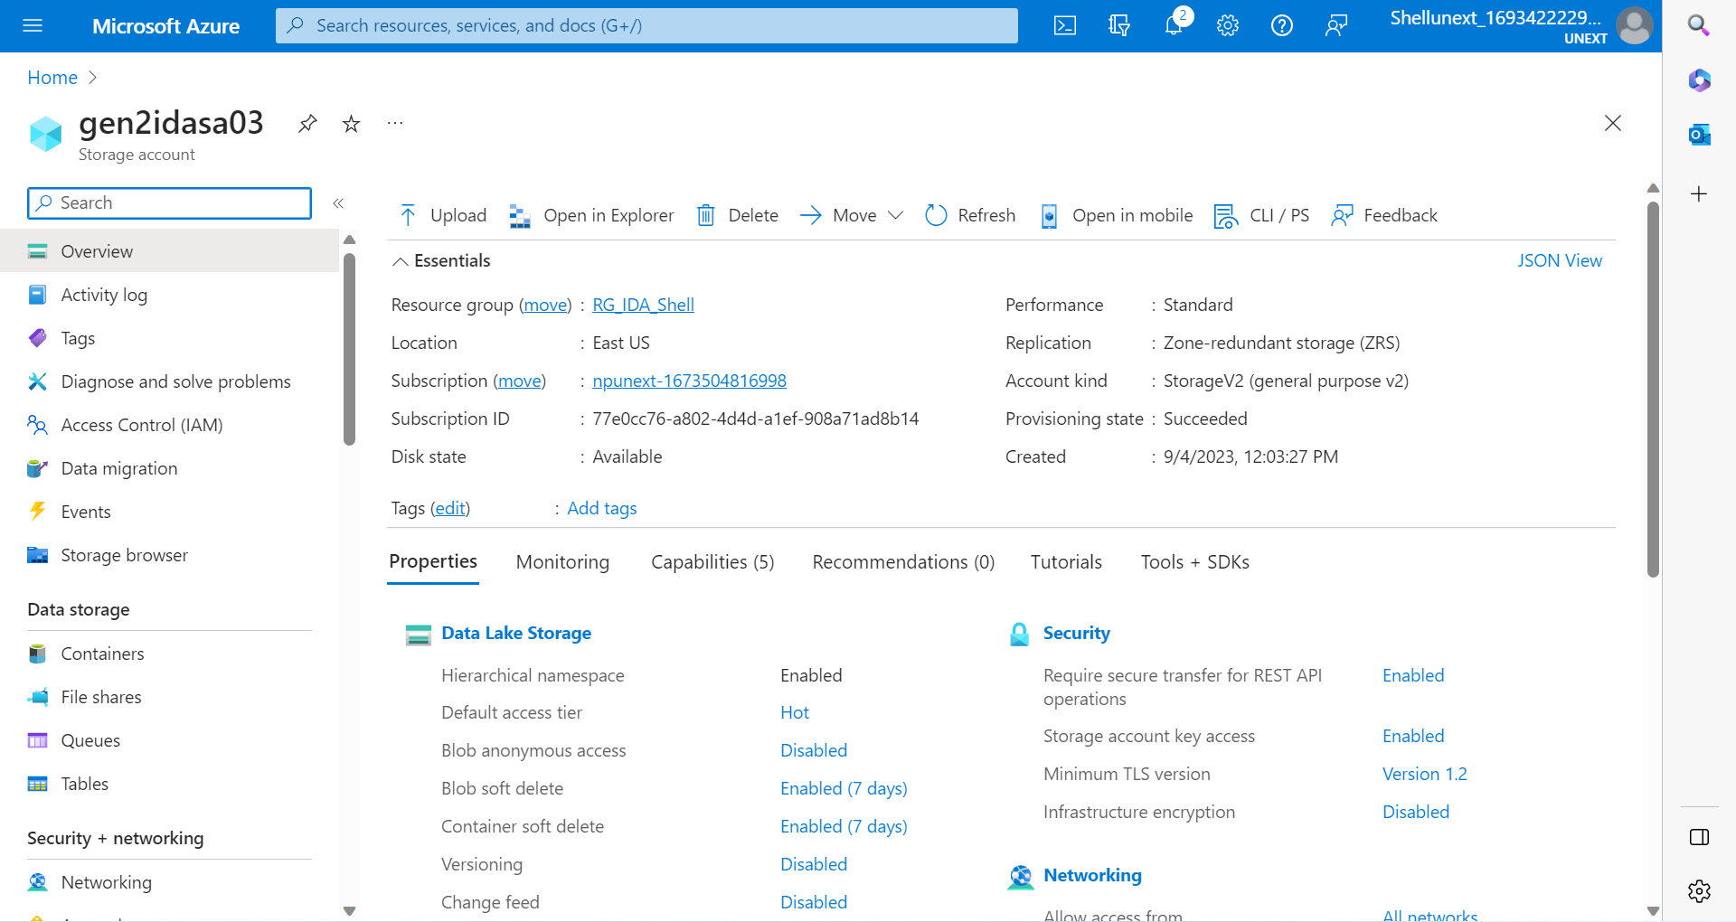

Creation and Connection of Virtual Machine:

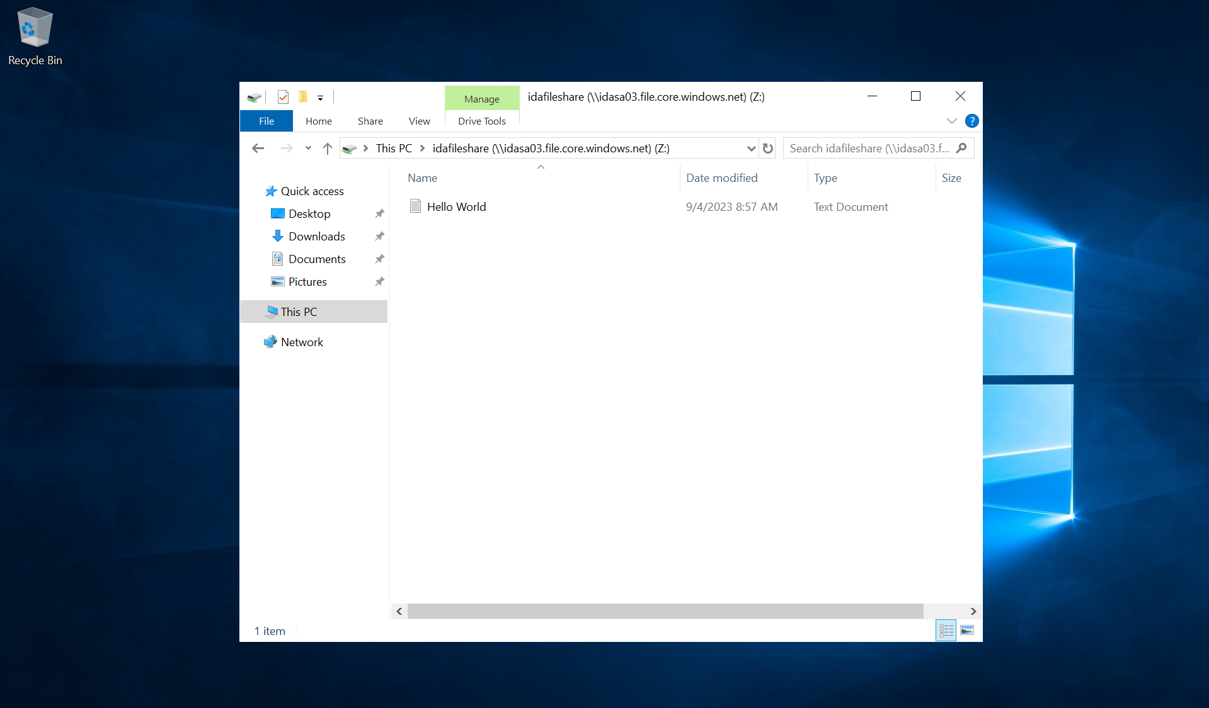

For file share:

* Create an Azure Data Lake Storage Gen2
* Create a file share
* Click on connect
* Copy the script generated
* Upload a demo file in the file share
* Create a VM with windows 2019 image
* Connect to the VM using Remote Desktop Connection
* There run the script in windows PowerShell
* The file share is reflected in the VM, containing the demo file inside

Creation of fileshare:

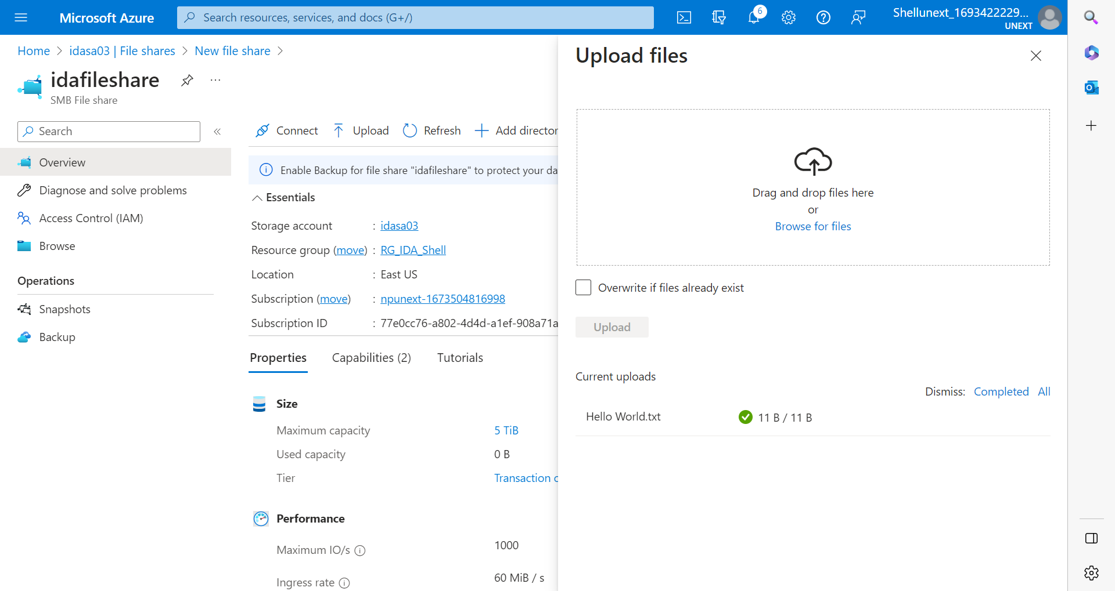

Snapshots:

* Snapshots keep a record of the file status
* To compare the changes that happen in a file, snapshots can be used
* To restore a file to a previous version, click on that particular snapshot and click restore

Adding Snapshots:

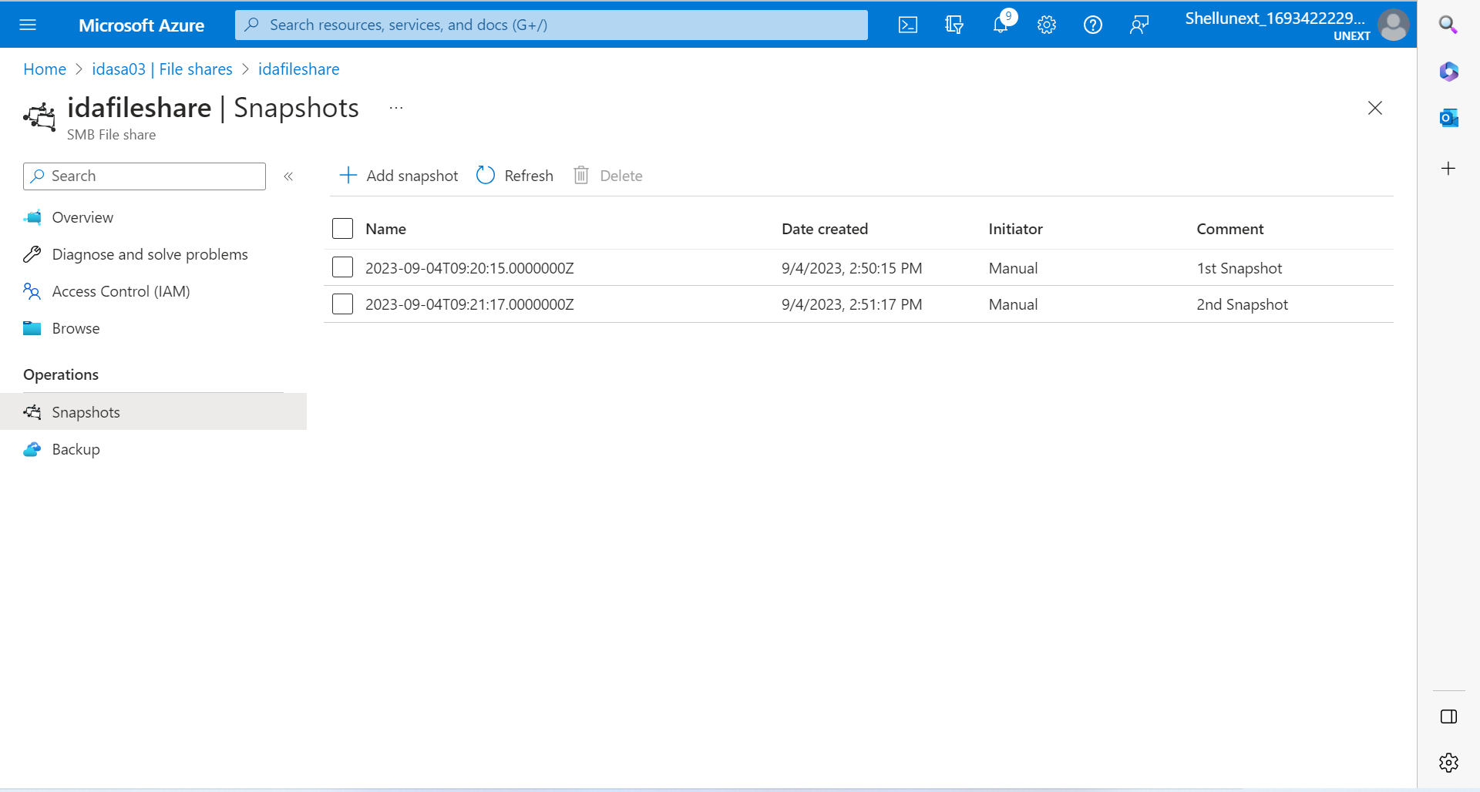

Restoration to previous Snapshot:

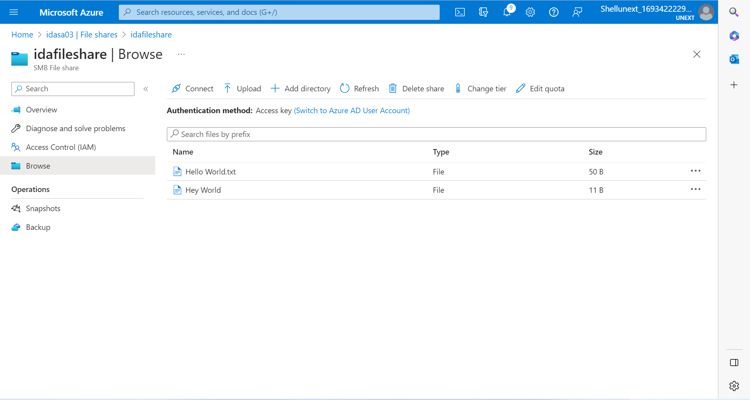

Creation of table and insertion of row data:

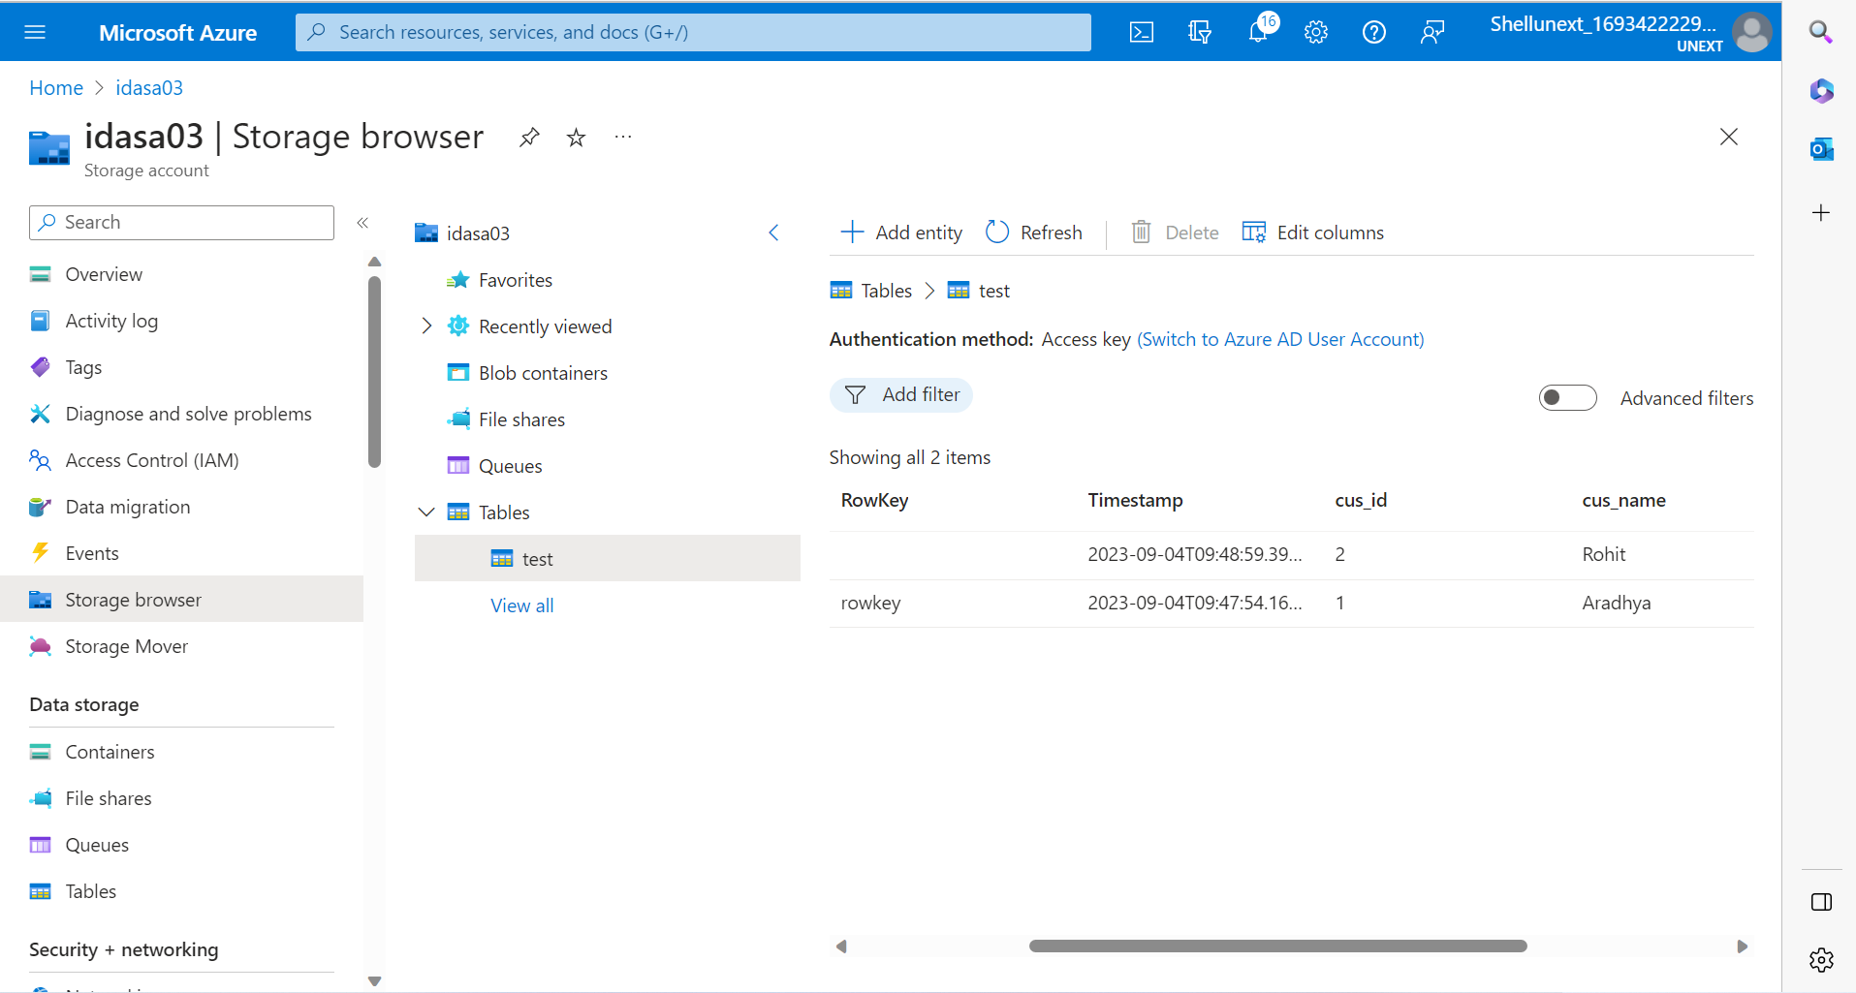

Azure Pricing Calculator

* To check the cost of different services
* Based on the region and other configurations the costs will change

Azure Total Cost of Ownership(TCO)

* Define your workloads
* A report will be generated detailing the billing amount of the Azure Services
* It also generates a report comparing the use of on-premises services and the services provided by Azure

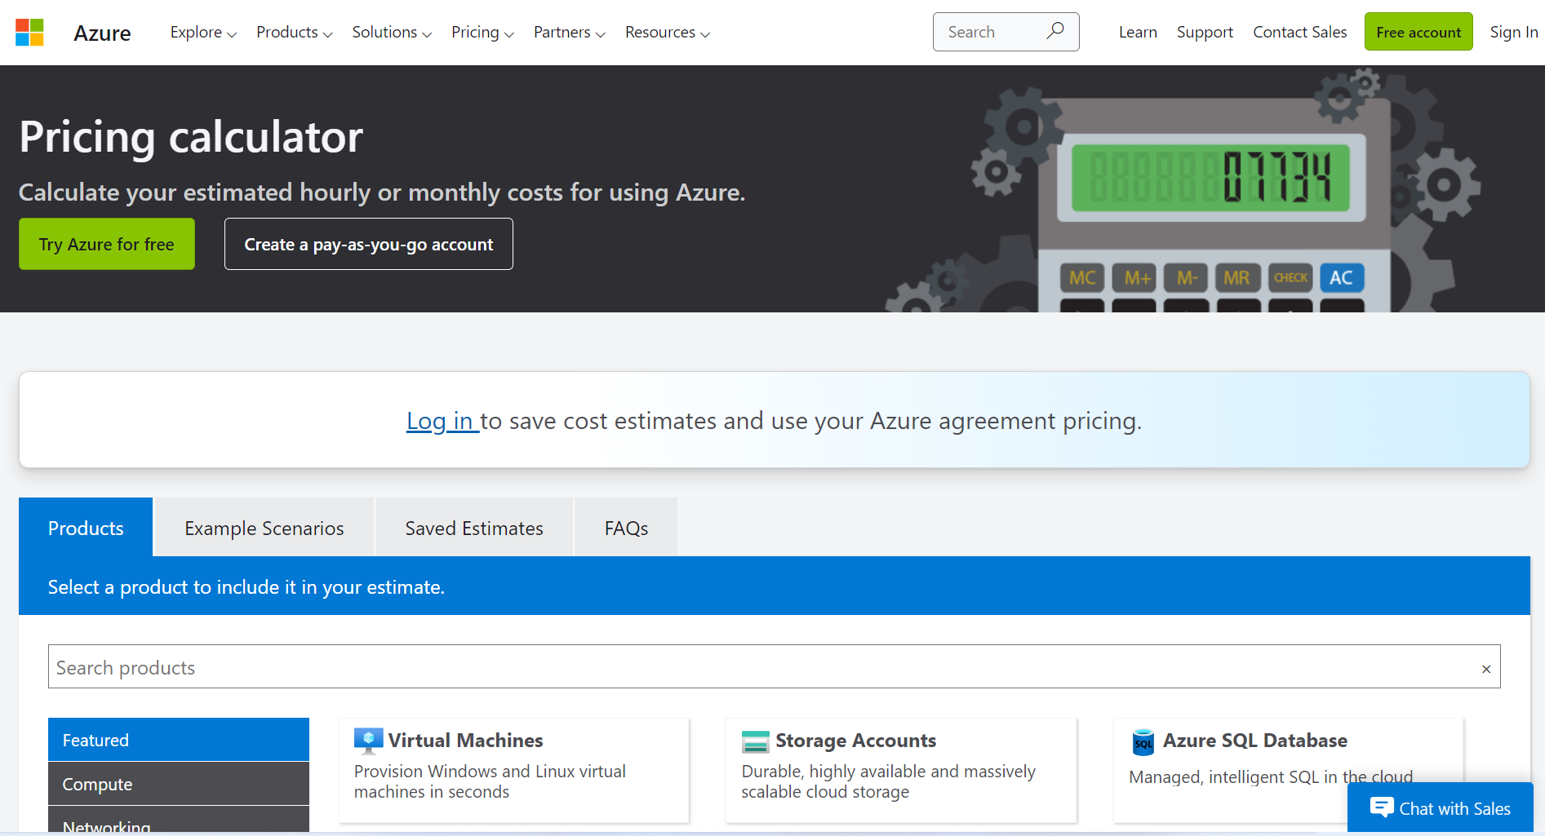

Ingress: Pushing data into Azure.

Egress: Downloading the data from Azure.

Egressing from one region to another will cost more than in the same region.

Task

* Check the costs of different services based on different configurations

Static Website

* Create html file
* Index.html
* Go inside storage account
* Inside container
* Disabled to enabled
* Index.html put the file name(index document name)
* Copy primary endpoint
* Paste the copied endpoint in the browser

***Note:

* Multiple static web applications can be created but only one can be executed at a time
* This is because there is only one endpoint that corresponds to one static application
* To run multiple web applications, they need to be linked such that running one on the browser causes other applications to run consecutively
* Example:
  + Multiple html files are uploaded in the container
  + Since only one can be run at a time, if the html file that is running calls the other html files in the form of different pages, multiple static applications execution can be achieved

Static Website Hosting:

